Blind - Braille Legislation Independence Navigation Determination 2026
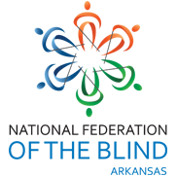
DONATION FORM
Please fill out, make a copy for your tax records, and return to:
David Henry
P O Box 3441
Bentonville, AR 72712
Email: rockinh57@cox.net
(479)426-7993

DONOR INFORMATION:
Donor Name (as you want it to be recognized)

Contact Name (individual who can be contacted about donation)

Mailing Address

City, Zip Code

Phone Number

Email Address

DESCRIPTION OF DONATION
Please write a description of the donated item:

Estimated Retail Value of Donated Item

Restrictions, Special Instruction or Notes (if applicable)

National Federation of the Blind of Arkansas Tax I.D.: 71-6057788

